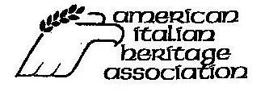
We are a national organization preserving our heritage since 1979.
Planning a national American-Italian Museum and Cultural Center in Albany, NY

Donor Recognition Tree of Life-
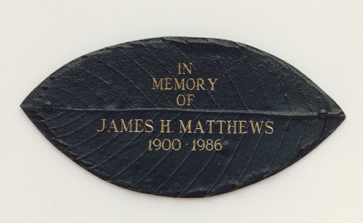
Your tax deductible donation to the American Italian Heritage Museum and Cultural Center will help promote, record and preserve our Italian Heritage.
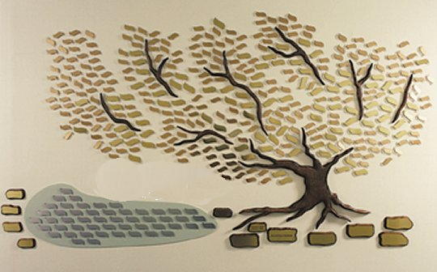

Photo Memorial Plaque closeup
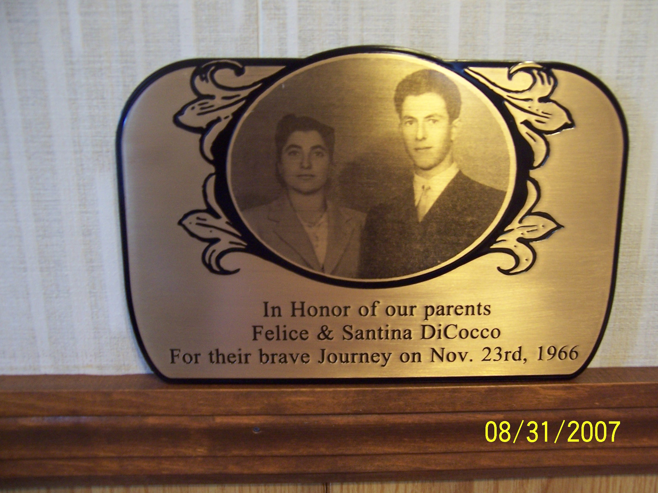
Sample design. Final drawing not yet approved.
Our stunning Donor Recognition Tree will be prominently displayed in the main lobby. The tree will occupy a main wall 12’ wide and 8’ high. It will have beautiful leaves made out of brass, nickel and bronze. Each leaf will designate those who have so generously gifted to our Donor Tree campaign. In addition, each tree will also feature a limited number of photo memorial plaques, approximately 8-1/2” x 5-3/4” to be installed at the bottom of the trunk.
You, your family or your business will have your name and/or special message on a leaf or a plaque by making a gift to our Donor Tree Campaign. Your generosity will be available for all to see. Your donation will help complete the renovations to the Museum building, and support its opening.
Yes, I would like to make a tax deductible contribution to the American-Italian Museum and Cultural Center.

____Bronze- $275
____Gold - $350
____Platinum - $500
____Photo Plaque - $2500
Name _________________________________
Address________________________________
Phone__________________
Email:__________________________________
Inscription: (up to 80 characters including punctuation and spacing can be imprinted on your leaf. Up to 150 characters on three lines including punctuation and spacing can be imprinted on the Photo Memorial Plaque.) ____________________________________________________________
____________________________________________________________
____________________________________________________________
Make check payable to American Italian Heritage Association and mail to :
Cathy McGuire, Fundraising Chairperson, 1222 Angelo Dr. Schenectady NY, 12303
Or Call 355-2595 or 355-5690 for questions.

